Networking Report

* Part 1 complete

Scenario 1 Normal (Part 1):  
The server is creating a socket and binds it. The process starts by sending the file metadata. We can see that the operation is successful from the message SERVER: Meta info is received successfully: file name (output.txt), size (220).

Then the file is sent. The server is waiting for data to be received. Each time the server is receiving a segment (frame) it prints the sequence number, the size, the checksum and the content. Then it checks if the checksum is correct and it sends back an acknowledgement with the same sequence number of the data received.

I don’t need to consider issues that affect the segment while travelling through the network in this scenario.

S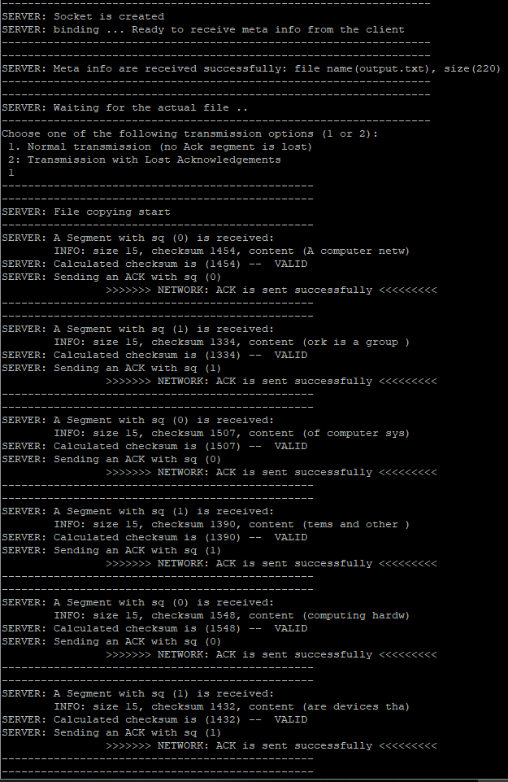

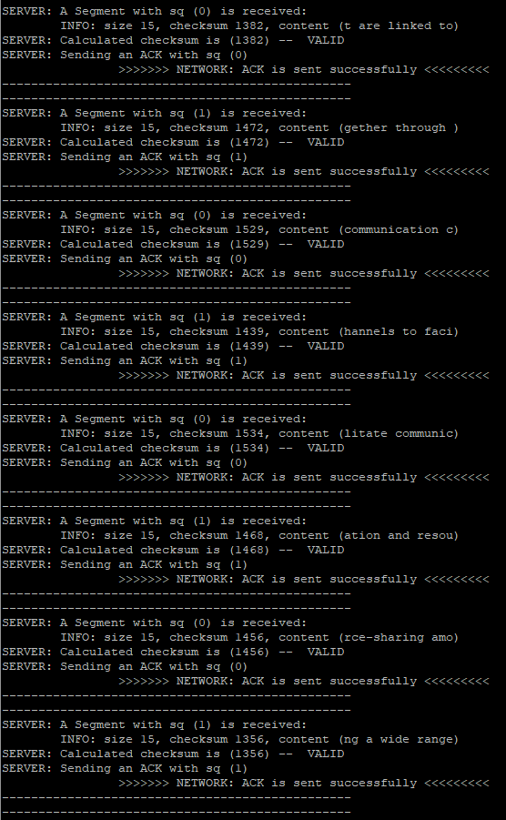

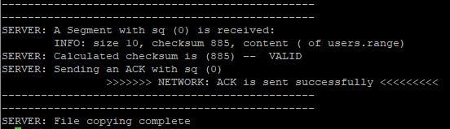

The client: prepares the data to be sent and creates the socket.

Then it divides the file into several segments where each segment's payload contains 15 characters. While creating a segment, it defines the type, the size, and a sequence number and calculates the checksum. It sends a frame at a time checking for errors and receives an ACK that should have the same sequence number as the segment sent.

